***Introduction:***

The Online Movie Ticketing System, named MovieMagic, is a web application developed for the Business Application Development module at the Faculty of Business, University of Moratuwa. The project is designed to provide users with a convenient platform to access information about recent and trending movies, make bookings, and manage their movie tickets. Developed using PHP for the backend and Bootstrap, CSS, HTML, and JavaScript for the frontend, MovieMagic aims to simplify the process of purchasing movie tickets, allowing users to seamlessly book and cancel tickets based on theatre type and class. The system also provides features to check the status of booked tickets, enhancing the overall movie-going experience.

***Installation Process:***

To set up MovieMagic, users are required to install XAMPP and configure PHP and MySQL. The installation involves importing the 'cinema_db.sql' file into PHPMyAdmin, updating database connection details in 'Connection.php' and 'config.php' files for user and admin purposes, respectively. The admin panel credentials are provided for secure access. The system is built to ensure a straightforward installation process, enabling users to quickly deploy the application and start using its functionalities.

***Admin Dashboard:***

The admin dashboard, accessible through 'admin.php', serves as the central hub for system management. It provides real-time statistics on the number of bookings, feedback messages, movies, and registered users. The dashboard uses icons and color-coding to visually represent these statistics, enhancing user experience. Additionally, the system displays a table of recent bookings, offering detailed information such as booking ID, movie ID, user details, and order ID. The use of DataTables improves the readability and interactivity of the table, providing a comprehensive overview of recent activities within the system.

***User Authentication and Security:***

The user authentication process is implemented in 'index.php', requiring users to input their username and password. The provided credentials are then verified against the database, and upon successful authentication, users are redirected to the admin dashboard. The system employs MySQLi functions to prevent SQL injection and enhance overall security. The login form is designed with a responsive layout using HTML and CSS, providing an aesthetically pleasing and user-friendly interface. This combination of security measures and user-centric design ensures a secure and seamless experience for administrators accessing the MovieMagic system.

This online movie ticketing system, with its user-friendly interface, robust admin dashboard, and emphasis on security, aims to simplify the movie ticket booking process and enhance the overall user experience for both administrators and end-users.

*User Guide:*

# Online-Movie-Ticketing-System

Web Application project for the Business Application Development module taught at Faculty of Business University of Moratuwa

# MovieMagic (Movie Ticket Booking System-PHP)

MovieMagic, back-end coded with PHP and front-end coded with Bootstrap, CSS, HTML, and Javascript and used MySql in the database.

The MovieMagic facilitates the users to enquire about the recent movies available movies, booking, and cancellation of movie tickets according to theatre type and class type, enquire about the status of the booked tickets, etc.

The aim of this project is to design a website that gives an easy platform for people to get details of trending films and to get movie tickets in the easiest possible way making it simple for all to buy tickets from anytime and anywhere.

## Installation

install XAMPP and setup php mysql

## php (for user Purpose)

1) Open PHPMyAdmin

2) import 'cinema_db.sql'

3) Open Connection.php and update db_name and password.

4) Go to admin Folder and Open config.php and update db_name and password.

## Admin Panel

Username:- Nithi99

Password:- 123

## Created By

Pahirathan Nithilan: (https://github.com/Pahinithi)

## modified by

T.Viploon: (https://github.com/vipoolan)

T.Akulapiriyan: (https://github.com/Piriyan98)

W.Robina: (<https://github.com/2001-01-01>)

Video_Guide: <https://drive.google.com/file/d/1RFg5OF398fFif6kxrU3xSxqe7lX7lXxQ/view?usp=sharing>

***Home Page:***

The provided HTML code appears to be the structure of a web page for a movie booking platform named "MovieMagic." The page is divided into several sections, including a header, a trending movie section with booking options, a section explaining how the platform works in three simple steps, and a section showcasing trailers for currently showing movies. The page uses PHP to retrieve and display movie information from a database, allowing users to book tickets for their favorite movies. It also incorporates FontAwesome icons for visual elements and includes external CSS and JavaScript files for styling and functionality. The footer section is present but currently empty. Overall, the structure suggests a user-friendly interface for exploring and booking movies, with an emphasis on simplicity and visual appeal.

***Schedule Page:***

The provided HTML code appears to be a webpage for displaying a schedule of movie showtimes at various cinema halls. The page includes a header with a logo, a "Movies Schedule" title, and a navigation bar. The main content consists of a schedule section with date options and a table displaying details about a movie named "LEO" at different cinemas. Each row in the table represents a cinema location, providing information about the movie, its duration, and the cinema's name and location. Additionally, the schedule for different hall types (Private Hall, VIP Hall, Main Hall) is presented with specific showtimes. The page utilizes FontAwesome icons, a custom stylesheet, and external JavaScript libraries (jQuery and Owl Carousel) for enhanced functionality. It is structured with HTML5 semantics and includes a footer at the bottom of the page.

***Contact Page:***

The "contact_us.php" file appears to be a webpage designed for users to submit feedback or inquiries. The page includes a form with fields for the user's first name, last name, email address, and a message. Upon submitting the form, the provided information is processed using PHP, and if successful, it is inserted into a database table named "feedbackTable." A confirmation message is displayed using JavaScript. The page also includes contact information such as phone numbers, address, and email, along with a Google Map embedded in an iframe. The header and footer sections suggest a structured layout, and external resources like stylesheets and scripts are linked for styling and functionality. Overall, the page seems well-organized and user-friendly, facilitating communication with users and providing essential contact details.

***Booking Page:***

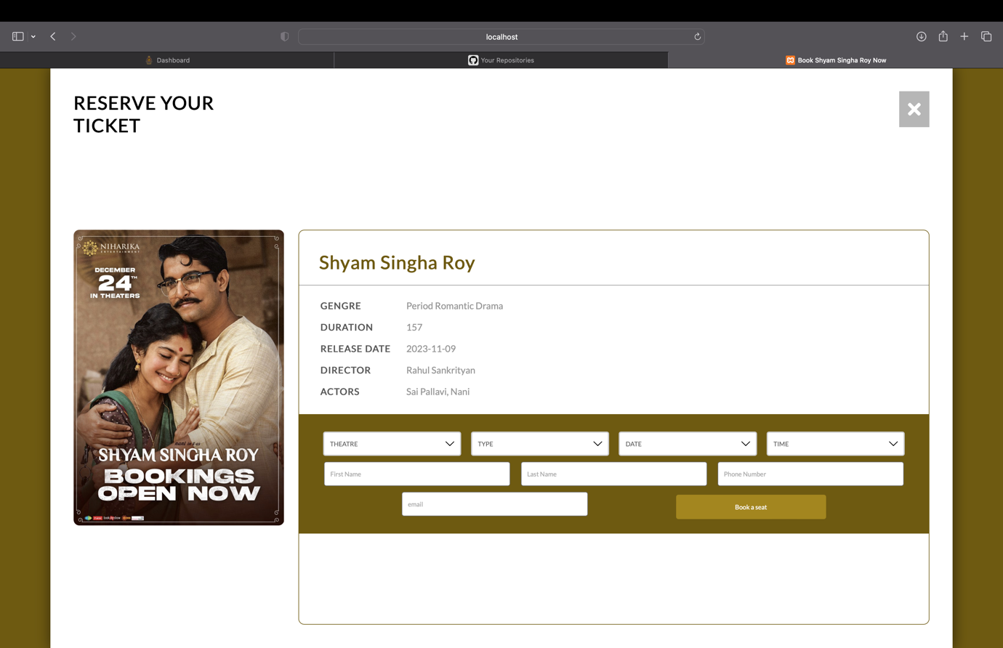

The provided PHP script, "booking.php," serves as a booking page for a movie reservation system. It retrieves movie information based on the 'id' parameter from the URL, and if the parameter is not set, it redirects the user to the index page with an alert. The page features a responsive layout with movie details, including an image, title, genre, duration, release date, director, and actors. A booking form allows users to select a theater, movie type, date, and time for the reservation. Additionally, users input their first and last names, phone number, and email. The form submits the data to "verify.php" for processing, including the hidden movie ID. The page uses JavaScript to handle closing the booking panel and includes external style and script files for enhanced functionality and aesthetics.

***Admin/index Page:***

The provided code represents a simple login page (admin/index.php) with accompanying PHP logic for authentication. The HTML structure defines a form within a styled container, featuring input fields for username and password. The PHP section includes a connection to a database (assumed to be configured in "config.php") and handles user login attempts. Upon form submission, it retrieves and sanitizes the entered username and password, checks the credentials against a database table ("users"), and redirects to an "admin.php" page if the login is successful. However, the code lacks certain security measures, such as hashing passwords and preventing SQL injection. It's essential to enhance the code by incorporating best practices for secure authentication, like using prepared statements and password hashing. Additionally, session management appears to be utilized, storing the username in the session upon successful login.

***Booking Summery/Payment Page:***

The provided PHP file, "receipt.php," generates an invoice receipt for a movie booking. It utilizes HTML and Bootstrap for styling, creating a responsive design. The invoice includes details such as the MovieMagic branding, invoice number, creation date, due date (set to 24 hours after creation), customer information, payment status, and movie details like date, theater type, and movie type. The payment status is set to "Success," and the amount paid is displayed in Sri Lankan Rupees. Additionally, a QR code is generated using the PHP QR Code library, containing various booking details. The user is given the option to print the receipt or return to the home page. The code also includes a link to an external JavaScript file, "_js.js," which appears to be missing from the provided code snippet. The PHP code fetches booking information from a database based on the provided ORDERID parameter, and if the ORDERID is not present, it redirects the user to the home page.

***Admin panel:***

The provided PHP script appears to be an admin dashboard page for managing a movie booking system. The dashboard includes statistics panels displaying the number of bookings, movies, users, and messages. These statistics are retrieved from a MySQL database using SQL queries. The page features an attractive layout with icons and colored panels for visual representation. Additionally, the script fetches and displays recent booking details in a table, including information such as booking ID, movie ID, customer name, contact details, booking date, theatre, booking type, and order ID. The use of Bootstrap and DataTables enhances the overall design and functionality of the admin dashboard, providing a user-friendly interface for administrators to monitor and manage the movie booking system. It's important to note that the script checks for user authentication before allowing access to the admin dashboard, redirecting unauthenticated users to the login page.

***Admin Panel / Booking Details Page:***

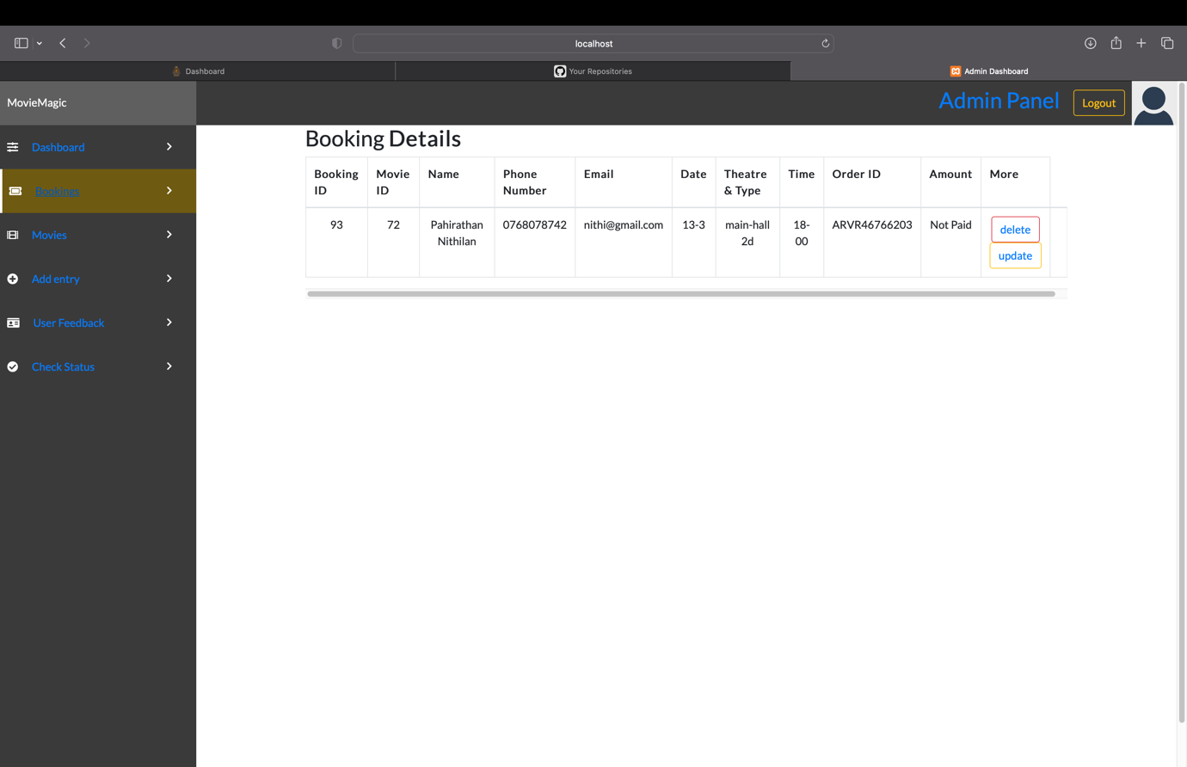

The provided PHP code appears to be a part of an admin view page for managing booking details in a web application. The page includes essential components such as a navigation header, a sidebar for navigation, and a table displaying booking details retrieved from a MySQL database. The table contains columns for Booking ID, Movie ID, Name, Phone Number, Email, Date, Theatre & Type, Time, Order ID, and Amount. The data is fetched from the "bookingtable" in the database, and each row provides options to delete or update a booking through corresponding buttons. Additionally, the page incorporates external stylesheets and scripts for styling and functionality, including the use of DataTables for enhanced table features. The code also ensures that only authenticated users can access the page, redirecting unauthenticated users to the login page. Overall, this code snippet contributes to an admin dashboard for efficiently managing and viewing booking details in a user-friendly manner.

***Admin Panel / Movie Add Page:***

The provided PHP file, "admin/addmovie.php," appears to be a part of an admin dashboard for managing movies in a cinema database. The dashboard includes sections for adding new movies and displaying recent movies with options to delete them. It utilizes PHP for server-side scripting along with HTML for structuring the web page. The page includes essential elements like a navigation header, a sidebar for navigation, and form inputs for adding movie details. The form submission is handled within the same file, where the user input is processed and inserted into the movieTable of the cinema database. The dashboard also dynamically displays the number of bookings, messages, and movies in the system. Additionally, it employs external libraries and stylesheets, such as Bootstrap and DataTables, for enhanced styling and functionality. The code appears to have features for user authentication and session management to ensure secure access to the admin dashboard.

***Admin Panel / Theatre add Page:***

The provided PHP script, "admin/add.php," appears to be a web page for adding entries to a cinema booking system. The page includes features such as user authentication, session management, and a form for entering details like the type of theatre, movie format, date, time, customer information, and movie ID. The form submits data to "spot.php" using the POST method. The page is designed with a responsive layout, making it suitable for different device screen sizes. Additionally, the script connects to a MySQL database ("cinema_db") to retrieve counts of bookings, feedback messages, and movies, which might be displayed elsewhere on the page. Overall, the script seems to be part of an administrative interface for managing cinema bookings, providing a user-friendly form for adding new entries to the system.

***Admin Panel / Customer feedback details Page:***

The provided code appears to be a PHP-based web page for managing customer messages in an admin panel. The page includes HTML and PHP code to display a table of customer messages retrieved from a database. The structure consists of a header, sidebar, and a main content area with a responsive table displaying information such as Message ID, First Name, Last Name, Email, and Feedback. The data is fetched from a 'feedbacktable' in the 'cinema_db' database. Each row in the table includes a "Delete" button that, when clicked, triggers a link to 'Deletecontact.php' with the corresponding message ID for deletion. The page also includes links to external stylesheets and scripts for styling and functionality. Overall, it provides a user-friendly interface for administrators to view and manage customer messages in a cinema-related context.